HEALTHCARE ANALYTICS PLATFORM - DESIGN SPRINT REPORT
Problem Statement:
Use patient data to improve care, predict risks and optimize operations.
Tech Stack:
Cloud Data Platform: Snowflake
Language: SQL
Data Loading: COPY INTO
Automation: Streams & Tasks
Historical Tracking: SCD Type 2
Visualization: Power BI Dashboards
Source Files: CSV Files
Tasks:
1. Patient 360
2. Risk Prediction
3. Revenue Trends
4. No-show Analysis
Architecture Diagram:
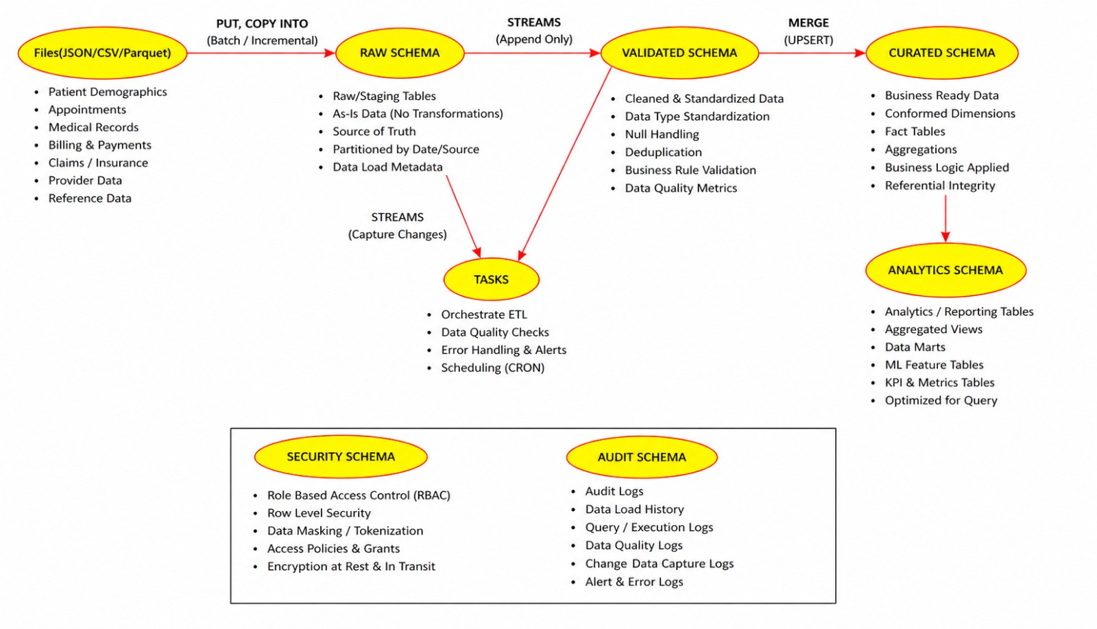
Use Case Diagram- HealthCare Analytics Platform:
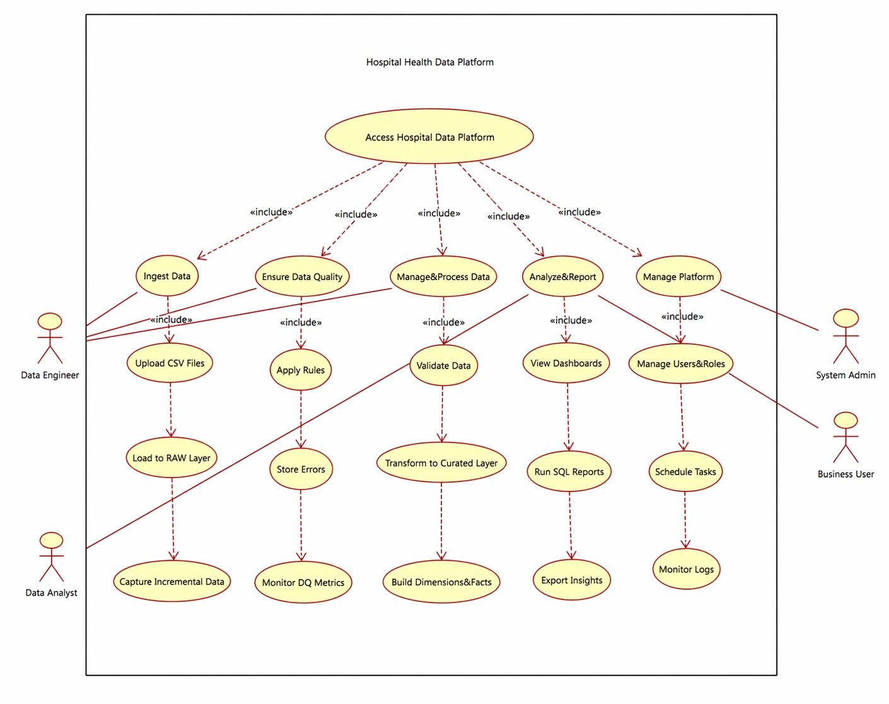

Activity Flow Diagram:
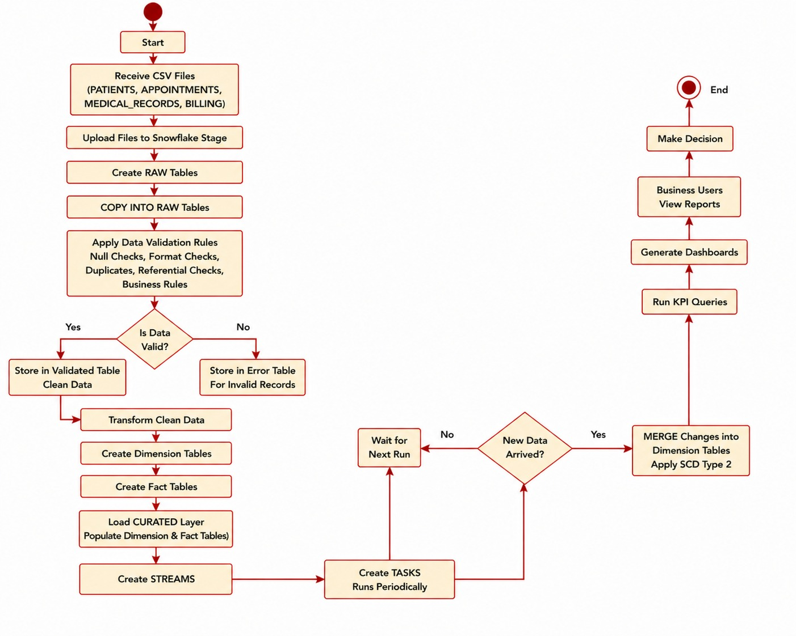

Data Mart:
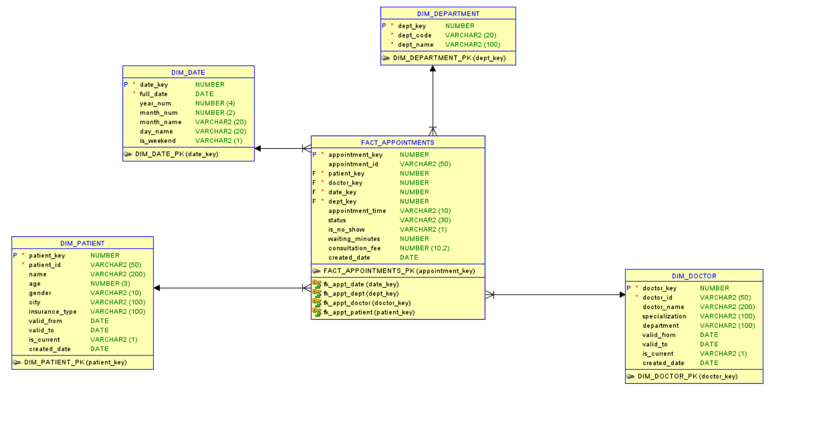
Conclusion:
This project demonstrates an end-to-end modern data engineering solution using Snowflake. It combines ingestion, validation, warehousing, automation, history tracking, and dashboards into one scalable healthcare analytics platform.

